ASSIGNMENT -3

1.
Promise.all([x, y, z])
.then(results => {
const total = results.reduce((p, c) => p + c);

console.log(`Results: ${results}`);
console.log(`Total: ${total}`);
});

2.
class Account{
constructor (public id: number , public name:string , public balance:number){

}
totalBalance(){
return this.balance;

}
class SavingsAccount extends Account{
constructor(id: number , name:string , balance:number, interest: number){
super(id ,name ,balance= balance+(balance*interest)/100);
}
}
class CurrentAccount extends Account{
constructor(id: number , name:string , balance:number , cash_credit: number){
super(id ,name ,balance= balance+cash_credit);

}

}
let savingsAccount =new SavingsAccount(9,"Pallavi",250000,10);
let currentAccount =new CurrentAccount(27,"Pallavi",250000,1000);

console.log(savingsAccount.totalBalance());
console.log(currentAccount.totalBalance());

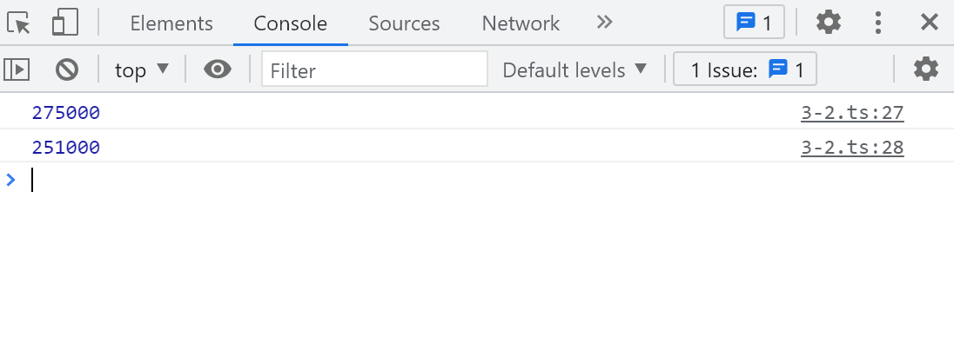

3.

interface Printable{
print():any;
}

let circle: Printable ={
print(){
console.log("circle obj");
}
}
let employee: Printable ={
print(){
console.log("employee obj");
}
}

function printAll(...objArr: Array<any>){
for(let i in objArr){
console.log(objArr[i].print())
}
}

